**Project Planning phase**

**Prepare milestone & Activity List**

|  |  |
| --- | --- |
| Date | 22 October 2022 |
| Team ID | PNT2022TMID30411 |
| Project Name | IOT based gadget Child Safety monitoring and notification |
| Maximum Marks | 4 Marks |

**Social/Emotional**

**o Wants to please friends**

**o Wants to be like friends**

**o More likely to agree with rules**

**o Likes to sing, dance, and act**

**o Is aware of gender**

**o Can tell what’s real and what’s make-believe**

**o Shows more independence (for example, may visit a next-door**

**neighbor by himself [adult supervision is still needed])**

**o Is sometimes demanding and sometimes very cooperative**

**Language/Communication**

**o Speaks very clearly**

**o Tells a simple story using full sentences**

**o Uses future tense; for example, “Grandma will be here.”**

**o Says name and address**

**Cognitive (learning, thinking, problem-solving)**

**o Counts 10 or more things**

**o Can draw a person with at least 6 body parts**

**o Can print some letters or numbers**

**o Copies a triangle and other geometric shapes**

**o Knows about things used every day, like money and food**

**Movement/Physical Development**

**o Stands on one foot for 10 seconds or longer**

**o Hops; may be able to skip**

**o Can do a somersault**

**o Uses a fork and spoon and sometimes a table knife**

**o Can use the toilet on her own**

**o Swings and climbs**

**Your Child at 5 Years**

**Child’s Name Child’s Age Today’s Date**

**How your child plays, learns, speaks, acts, and moves offers important clues about your**

**child’s development. Developmental milestones are things most children can do by a certain age.**

**Check the milestones your child has reached by his or her 5th birthday. Take this with you and talk with your child’s**

**doctor at every visit about the milestones your child has reached and what to expect next.**

**o Doesn’t show a wide range of emotions**

**o Shows extreme behavior (unusually fearful, aggressive,**

**shy or sad)**

**o Unusually withdrawn and not active**

**o Is easily distracted, has trouble focusing on one activity for**

**more than 5 minutes**

**o Doesn’t respond to people, or responds only superficially**

**o Can’t tell what’s real and what’s make-believe**

**o Doesn’t play a variety of games and activities**

**o Can’t give first and last name**

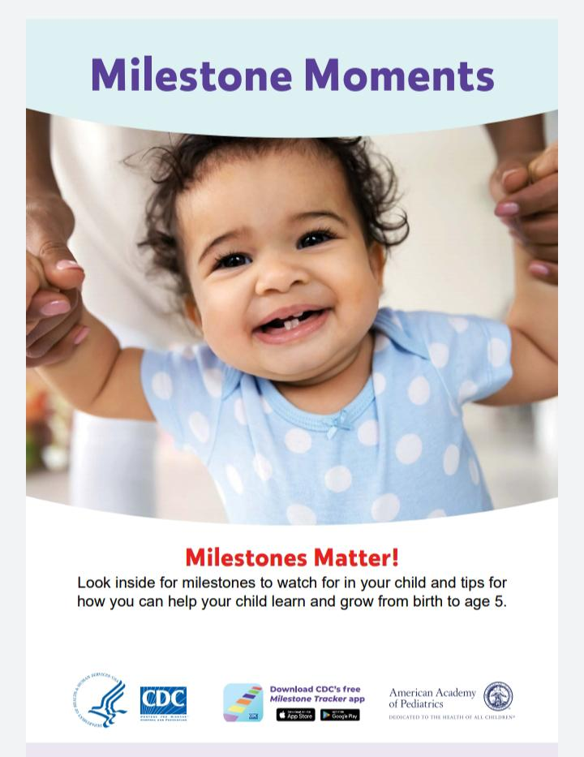**o Doesn’t use plurals or past tense properly**

**o Doesn’t talk about daily activities or experiences**

**o Doesn’t draw pictures**

**o Can’t brush teeth, wash and dry hands, or get undressed**

**without help**

**o Loses skills he once had**

**Tell your child’s doctor or nurse if you notice any of these**

**signs of possible developmental delay for this age, and talk**

**with someone in your community who is familiar with services**

**for young children in your area, such as your local public**

**school. For more information, go to www.cdc.gov/concerned**

**or call 1-800-CDC-INFO (1-800-232-4636).**

**Act Early by Talking to Your**

**Child’s Doctor if Your Child:**

**Adapted from CARING FOR YOUR BABY AND YOUNG CHILD: BIRTH TO AGE 5, Fifth Edition, edited**

**by Steven Shelov and Tanya Remer Altmann © 1991, 1993, 1998, 2004, 2009 by the American**

**Academy of Pediatrics and BRIGHT FUTURES: GUIDELINES FOR HEALTH SUPERVISION OF INFANTS,**

**CHILDREN, AND ADOLESCENTS, Third Edition, edited by Joseph Hagan, Jr., Judith S. Shaw, and**

**Paula M. Duncan, 2008, Elk Grove Village, IL: American Academy of Pediatrics. This milestone**

**checklist is not a substitute for a standardized, validated developmental screening tool.**

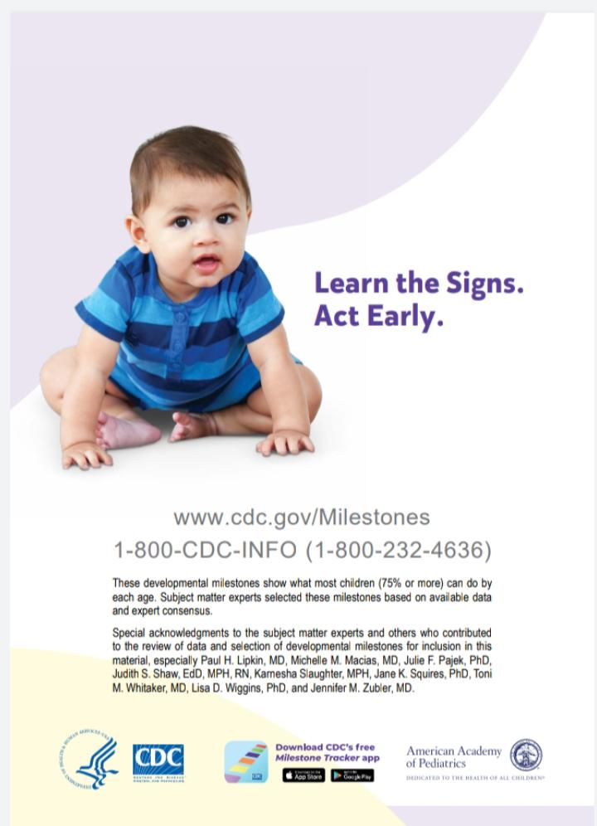

**How to Help Your Baby Learn and Grow**

**As your baby’s first teacher, you can help his or her learning and brain**

**development. Try these simple tips and activities in a safe way.**

** Respond positively to your baby. Act excited, smile, and talk to him**

**when he makes sounds. This teaches him to take turns “talking” back**

**and forth in conversation.**

** Talk, read, and sing to your baby to help her develop and understand**

**language.**

** Spend time cuddling and holding your baby. This will help him**

**feel safe and cared for. You will not spoil your baby by holding or**

**responding to him.**

** Being responsive to your baby helps him learn and grow. Limiting your**

**screen time when you are with your baby helps you be responsive.**

** Take care of yourself. Parenting can be hard work! It’s easier to enjoy**

**your new baby when you feel good yourself.**

** Learn to notice and respond to your baby’s signals to know what**

**she’s feeling and needs. You will feel good and your baby will feel**

**safe and loved. For example, is she trying to “play” with you by**

**making sounds and looking at you, or is she turning her head away,**

**yawning, or becoming fussy because she needs a break?**

** Lay your baby on his tummy when he is awake and put toys at eye**

**level in front of him. This will help him practice lifting his head up. Do**

**not leave your baby alone. If he seems sleepy, place him on his back**

**in a safe sleep area (firm mattress with no blankets, pillows, bumper**

**pads, or toys).**

** Feed only breast milk or formula to your baby. Babies are not ready for**

**other foods, water or other drinks for about the first 6 months of life.**